**Answer1 :** Class name is “Employee” and “EmployeeTest” (two packages created)

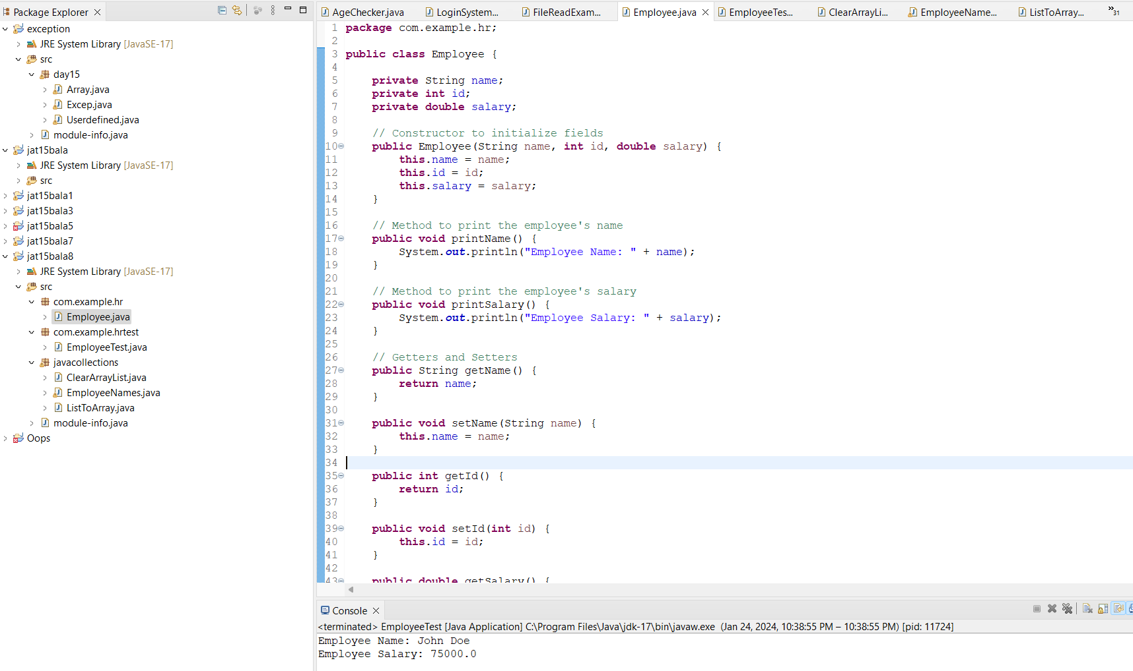

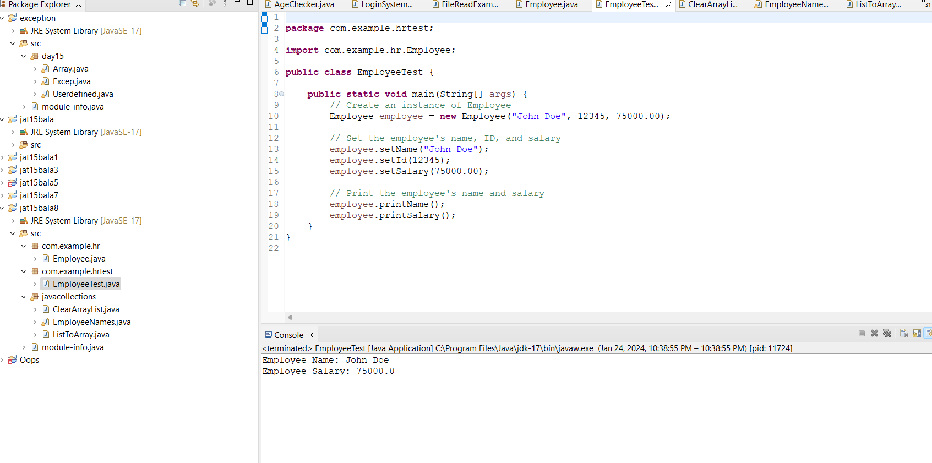

**Answer2 :** Class name is”ClearArrayList”

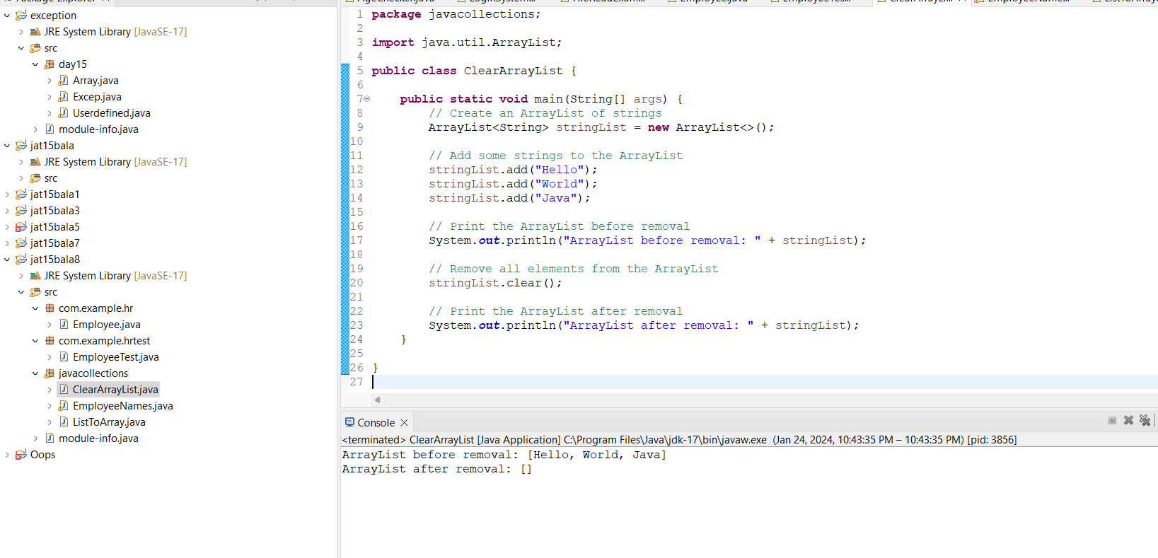

**Answer3 :** Class name is “EmployeeNames”

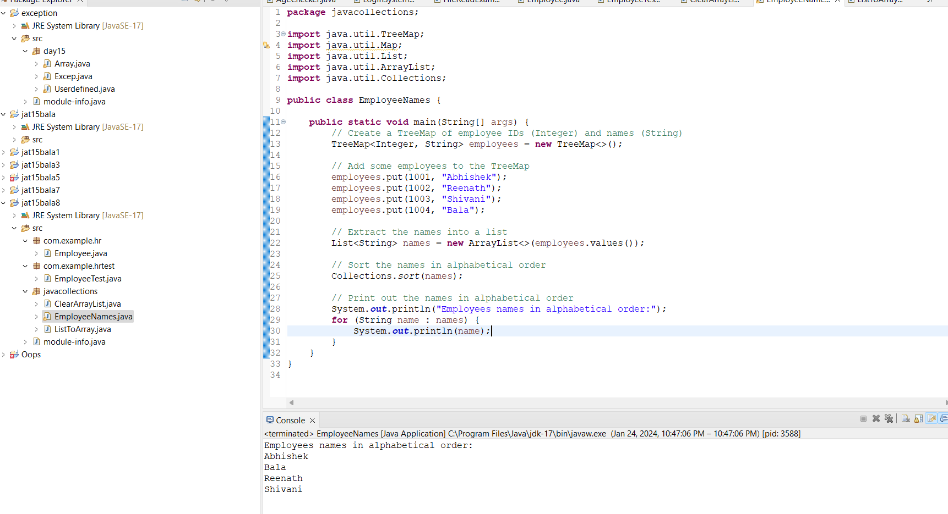

**Answer4 :** Class name is “ListToArray”

